A TASTE OF KINDERGARTEN
H.E. WHITE ELEMENTARY
Thursday, JUNE 23, 2022
9:00 A.M. – 2:30 P.M.
LUNCH PROVIDED

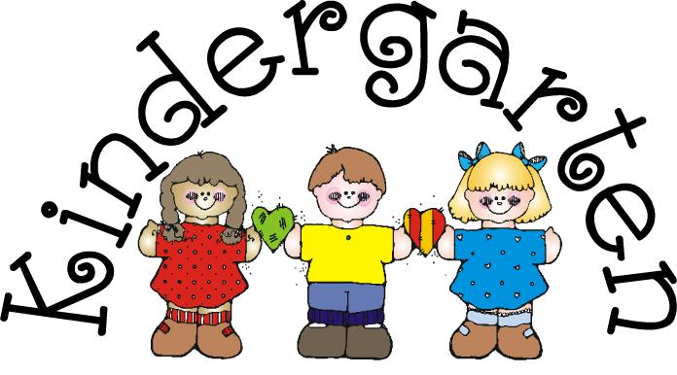

YOUR CHILD CAN ENJOY A DAY
IN THE LIFE OF A KINDERGARTENER!

MEET THE TEACHER!
LEARN KINDERGARTEN EXPECTATIONS!
RECEIVE FREE READING AND MATH MATERIALS!
HELP PREPARE YOUR CHILD FOR KINDERGARTEN!

RETURN THIS FORM TO YOUR CHILD’S SCHOOL BY Thursday, May 5th!

_____YES, MY CHILD AND I WILL ATTEND!
PARENT NAME:________________________________________
STUDENT NAME:_______________________________________

