Due to the finicky nature of the time sheets not opening in Edge, Google Chrome, Firefox or any browser other than the old Internet Explorer, this guideline will give direction on how to successfully open your time sheets each time.
The main issue with the form opening is that browsers attempt to open it using their own PDF readers. This is incompatible with the way that the forms are created.
The first step is to verify that you have Acrobat Reader installed on your computer.

Step 1. Verify Acrobat Adobe Reader is Installed
If you are unsure, simply type Adobe in your search window as shown below. If it populates an icon with Adobe Reader, it is already installed on your computer. If it is installed, please proceed to Step 4. Opening Timesheets in Adobe.
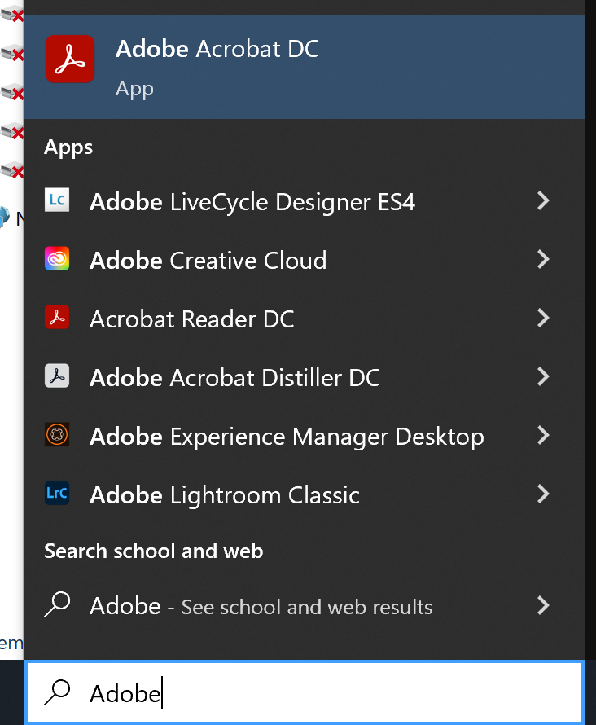

Step 2. Install Acrobat Reader
If you do not have Adobe Reader installed, select the link below to download it.
Adobe Reader Download
Be sure to uncheck any optional offers before selecting download.
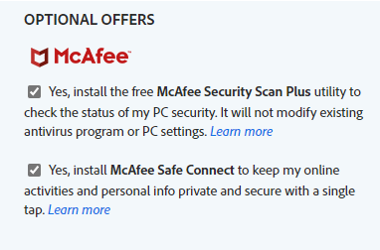
After deselecting any Optional Offers, select the following link as shown below.
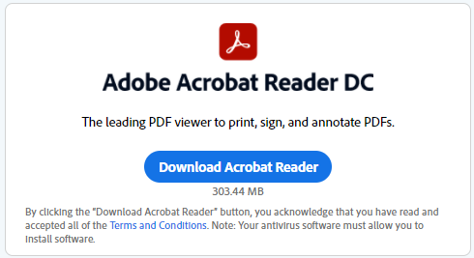
Once the file downloads, you will be presented the following prompt:
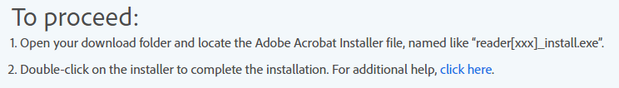

Step 3. Accessing the Downloaded File
After the download completes, the next step is to locate your “Downloads” folder and run the executable file.
You can access the downloads folder by going to “File Explorer” and opening the file there.
There should be a folder on your taskbar that looks like this. If not, just type “File Explorer” in your search bar.
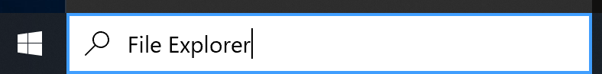
Open your downloads folder and look for the Adobe File.
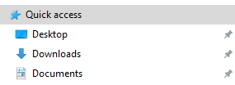
The file name is like this:
Double click it and follow the prompts.

Step 4. Opening Time Sheets in Adobe
Navigate to the Clay County Schools website, “Employee Resources” section.
Open the “Time Sheet Report” or whichever report you wish to use.
Select the time sheet and look for the following in the lower right-hand corner:
Use the down arrow to download the file.
Using the same steps as Step 3, go to your downloads folder and right click on the file.
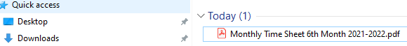
When you right click on the file, you will be presented with several options. You want to select:
“Open with Adobe Acrobat DC” or “Open with Adobe Acrobat Reader” or something similar to that.
If you do not see that option, you do not have Adobe installed. Go back to Step 2 and install Adobe first.
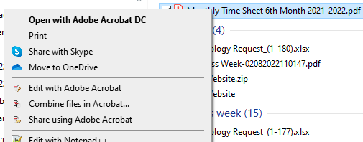
When you open PDF files using the outline above, it should always work for you. If you run into a situation where it doesn’t work, please report it and we will look at it.
Also, each pay period, I email the principals and secretaries at each location the original PDF document. If you are unable to download it, you can get a copy of it from them.

